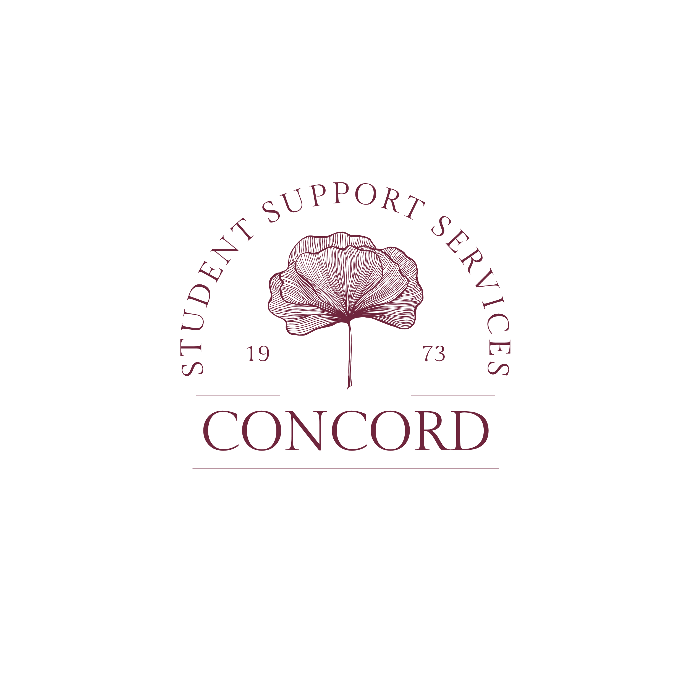

**SSS Fall 2024 Calendar**

**August**

**19 Classes Begin**

**21 Welcome Back – 10am – 2pm, SSS office**

**27-28 Recruitment table-11:00am-1pm**

**September**

**2 Labor Day-Campus Closed**

**3 Tutoring begins**

**4 Refresh for Success: SSP Event-10am-2pm**

**11 Real Talk: Darrick-4pm**

**October**

**5 Cultural trip-North Carolina Zoo**

**9 Mid-semester grades due**

**10-11 Fall Break**

**16 Paint Night: Bill**

**19 Homecoming**

**21-11/1 Advising for Course selection**

**28-11/1 Course Selection for Spring 2025**

**31 Halloween Event-10am-2pm**

**November**

1. **Last day of course selection for Spring 2025**

**13 Fun Event: Beth**

**20 SSS Open House, 10am-2pm**

**25-29 Thanksgiving Break**

**9 Final Exam Week (4/29 – 5/3)**

**December**

**6 Last day to drop or withdrawal**

**9-13 Final Exams**

**14 Commencement**

**17 Final Grades Due**